**REACT COURSE**

T Sree Sowmya

221910304044

Gitam Hyd CSE

**Day-5 8/12/2022**

**Revision of Functional component:**

**In functional Component create state called “Data”, initialize value of data as “GITAM”.create button “click” whenever we click on button value of data needs to be changed “GITAM HYDRABAD”**

import './App.css';

import {useState} from 'react';

import Gitam from './Gitam';

function App() {

  //let item="UNIVERSITY";

  const[data,setData]=useState("GITAM");

  function Updatedata()

  {

    setData("GITAM HYDERABAD");

    //alert(setData);

  }

  return (

    <div className="App">

    <h1>{data}</h1>

    <button onClick={Updatedata}>Click </button>

    </div>

  );

  }

export default App;

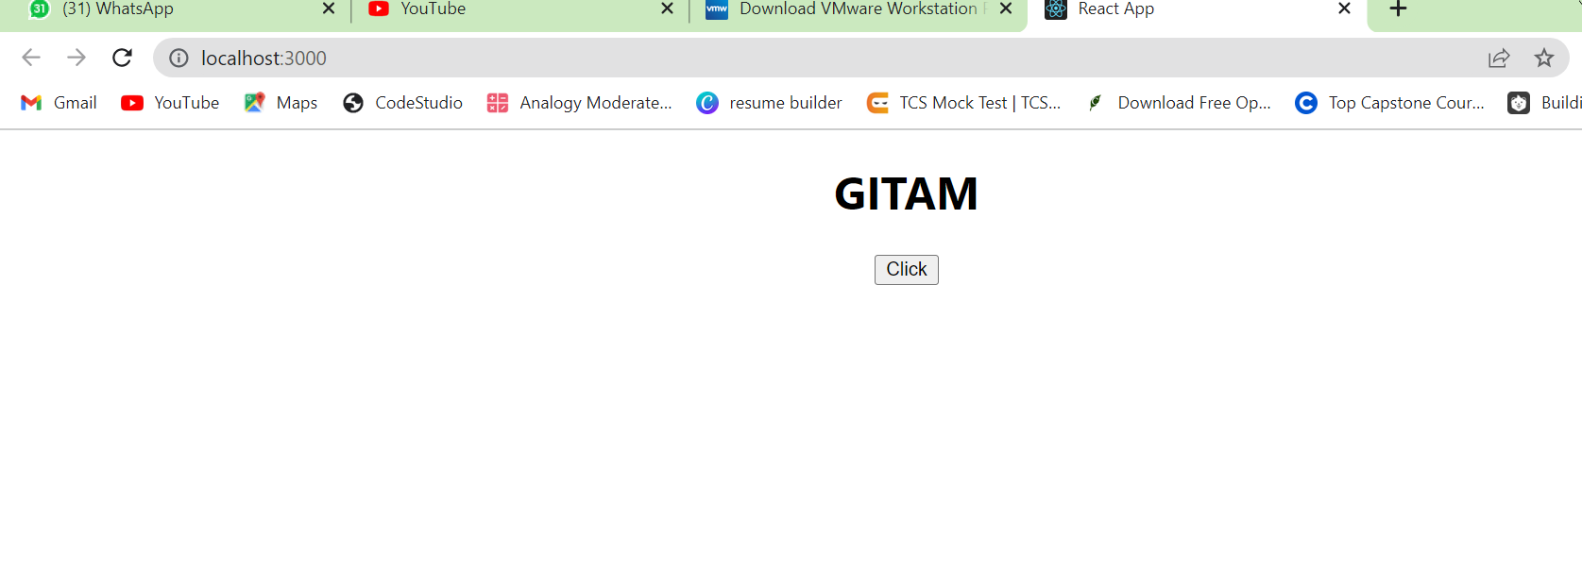

**PROPS:**

Props are nothing but properties or we will be calling it as “arguments".

**STUDENT.JS:**

Functional student(Props)

<div>

<h1>name:{Props.name}</h1>

<h1>Fname:{Props.Fname}</h1>

**APP.js:**

import './App.css';

import {useState} from 'react';

import Gitam from './Gitam';

import Student from './Student';

function App()

{

return (

<div className="App">

<h1>Props-</h1>

<Student Name={"Sowmya"}  email={"abc@gmail.com"}/>

<Student Name={"Virtusa"} email={"dcx@gmail.com"}/>

</div>

);

}

export default App;

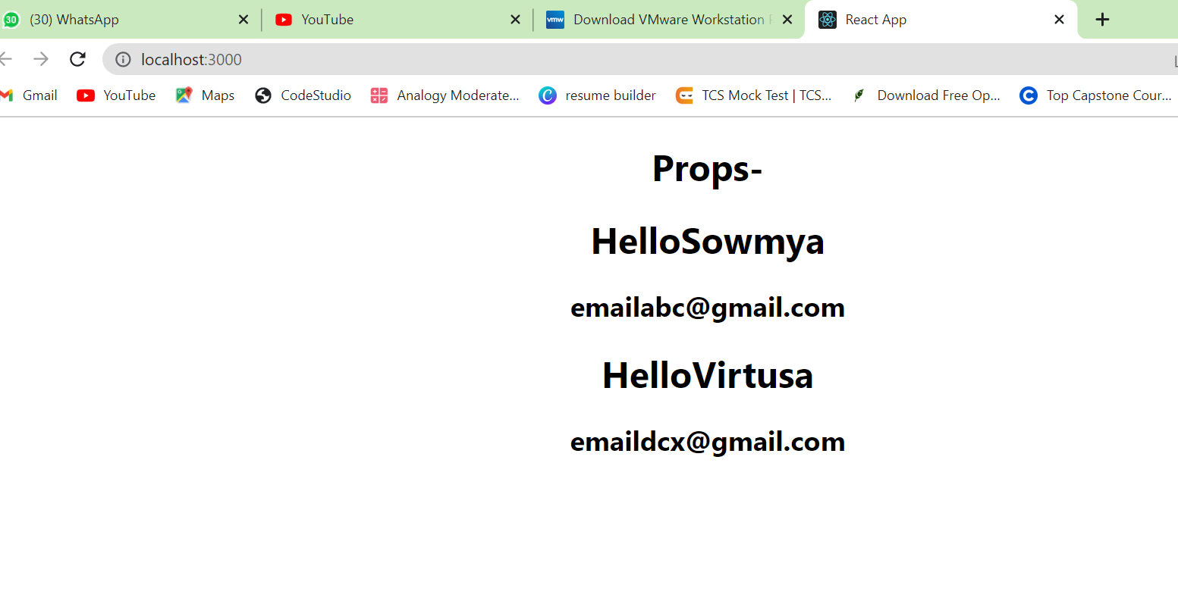

**Implementing Props in Functional component example:**

import './App.css';

import {useState} from 'react';

import Gitam from './Gitam';

import Student from './Student';

import User from './User'

function App()

{

return (

<div className="App">

<h1>Props--Example</h1>

<User Name1={"Mahesh"}Name2={"Suresh"} Name3={"T Sree Sowmya"} FName={"T V Ramam"} MName={"Anuradha"}/>

<User Name1={"Bulli"}Name2={"Sravanth"} Name3={"T Sree Sowmya"} FName={"T V Ramam"} MName={"Anuradha"}/>

</div>

);

}

export default App;

user.js

function User(Props) {

  return (

    <div>

      <h1>Name:{Props.Name1}</h1>

      <h2>Name:{Props.Name2}</h2>

      <h3>Name:{Props.Name3}</h3>

      <h1>F Name:{Props.FName}</h1>

      <h1>M Name:{Props.MName}</h1>

    </div>

  );

}

export default User;

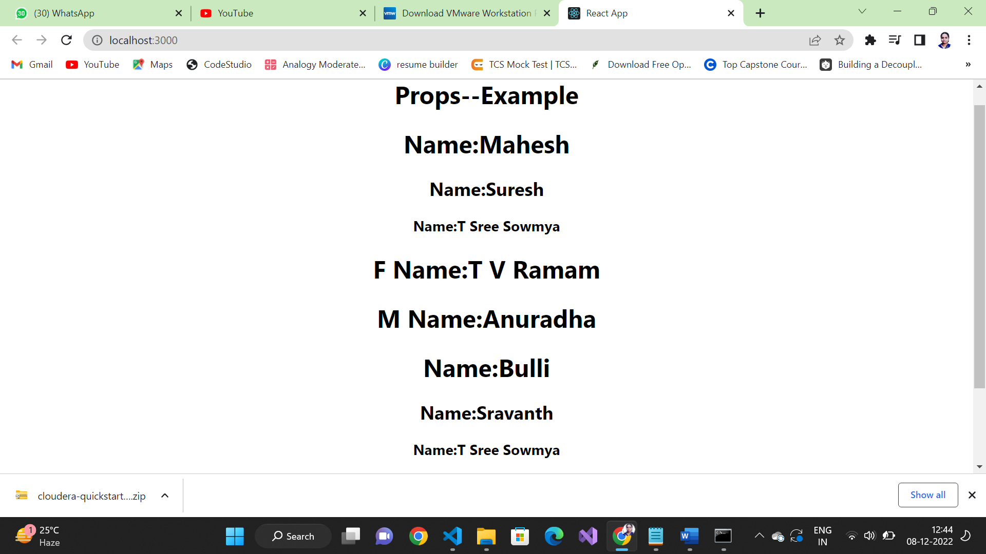

**Implementing Props in class component:**

**APP.JS**

import logo from './logo.svg';

import './App.css';

import {useState} from 'react';

import User from './User';

import React,{Component} from 'react'

class App extends Component

{

render()

{

    return (

        <div className="App">

        <h1>Props--Using Class Component</h1>

        <User Name1={"bULLI"}Name2={"Suresh"} Name3={"T Sree Sowmya"} FName={"T V Ramam"} MName={"Anuradha"}/>

        </div>

        );

}

}

export default App;

USER.JS

import React,{Component} from 'react';

class User extends Component

{

  render()

  {

  return (

    <div>

      <h1>Name:{this.props.Name1}</h1>

      <h2>Name:{this.props.Name2}</h2>

      <h3>Name:{this.props.Name3}</h3>

      <h1>F Name:{this.props.FName}</h1>

      <h1>M Name:{this.props.MName}</h1>

    </div>

  );

  }

}

export default User;

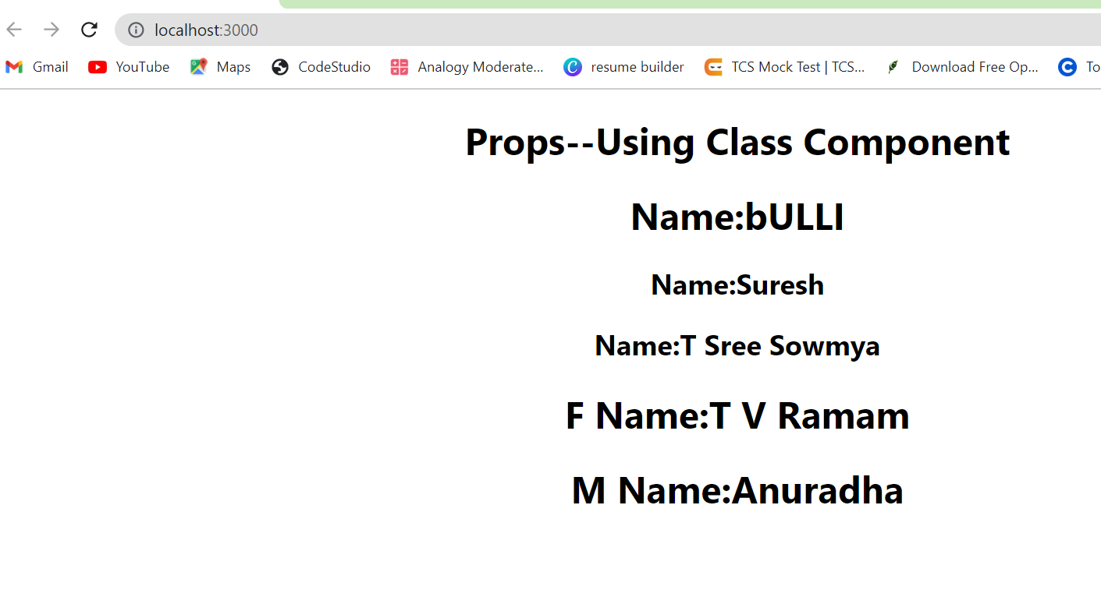

**ASSIGNMENT-3:**

1.Create a function called GITAM_YOURNAME and pass the Props as Surname,MobileNumber, Fathername .

Enter the minimum 10 values for the Props in App.js and Execute the application. This has be done using Functional Component

import './App.css';

import {useState} from 'react';

import GitamSowmya from './GitamSowmya';

import Student from './Student';

import User from './User'

function App()

{

return (

<div className="App">

<h1>Props--Example</h1>

<GitamSowmya SName={"Tanikella"} Name1={"Sowmya"} Pno={7995356725} FName={"T V Ramam"} MName={"Anuradha"} Edu={"B Tech"}

 Rno={221910304044} Year={"4th "} place={"Rudraram"} Mail={"221910304044@gmail.com"}/>

</div>

);

}

export default App;

GITAMSOWMYA.JS:

function GitamSowmya(Props){

  return (

    <div>

      <h2>Surname:{Props.SName}</h2>

      <h2>Name:{Props.Name1}</h2>

      <h2>MobileNumber:{Props.Pno}</h2>

      <h2>F Name:{Props.FName}</h2>

      <h2>M Name:{Props.MName}</h2>

      <h2>Education:{Props.Edu}</h2>

      <h2>Roll num:{Props.Rno}</h2>

      <h2>Year:{Props.Year}</h2>

      <h2>Place:{Props.place}</h2>

      <h2>mail:{Props.Mail}</h2>

    </div>

  );

}

export default GitamSowmya;

**OUTPUT:**

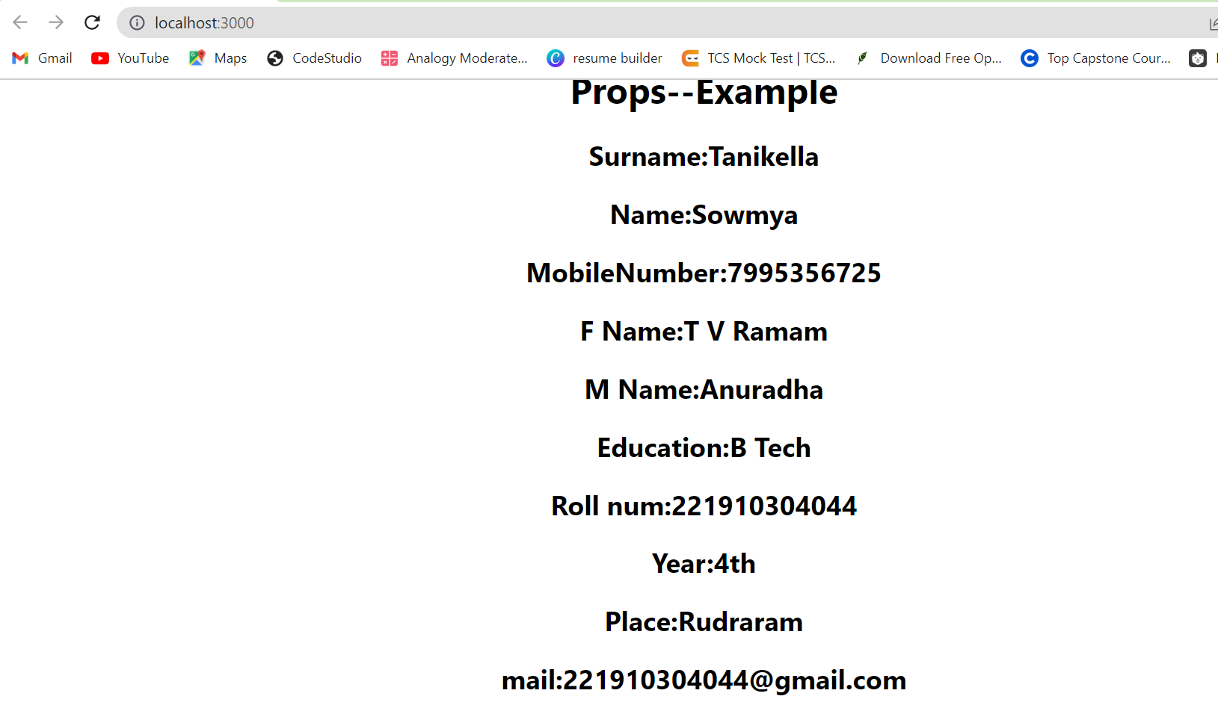

**2Q) Create a function called YOURNAME_GITAM and pass the Props as Surname,MobileNumber, Fathername .Enter the minimum 10 values for the Props in App.js and Execute the application. This has be done using ClassComponent**

import './App.css';

import {useState} from 'react';

import GitamSowmya from './GitamSowmya';

import Student from './Student';

//import User from './User'

import React,{Component} from 'react';

class App extends Component

{

render()

{

return (

<div className="App">

<h1>Props--class component</h1>

<GitamSowmya SName={"Tanikella"} Name1={"Sowmya"} Pno={7995356725} FName={"T V Ramam"} MName={"Anuradha"} Edu={"B Tech"}

 Rno={221910304044} Year={"4th "} place={"Rudraram"} Mail={"221910304044@gmail.com"}/>

</div>

);

}

}

export default App;

import React,{Component} from 'react';

class  GitamSowmya extends Component

{

  render()

  {

  return (

    <div>

      <h2>Surname:{this.props.SName}</h2>

      <h2>Name:{this.props.Name1}</h2>

      <h2>MobileNumber:{this.props.Pno}</h2>

      <h2>F Name:{this.props.FName}</h2>

      <h2>M Name:{this.props.MName}</h2>

      <h2>Education:{this.props.Edu}</h2>

      <h2>Roll num:{this.props.Rno}</h2>

      <h2>Year:{this.props.Year}</h2>

      <h2>Place:{this.props.place}</h2>

      <h2>mail:{this.props.Mail}</h2>

    </div>

  );

}}

export default GitamSowmya;

